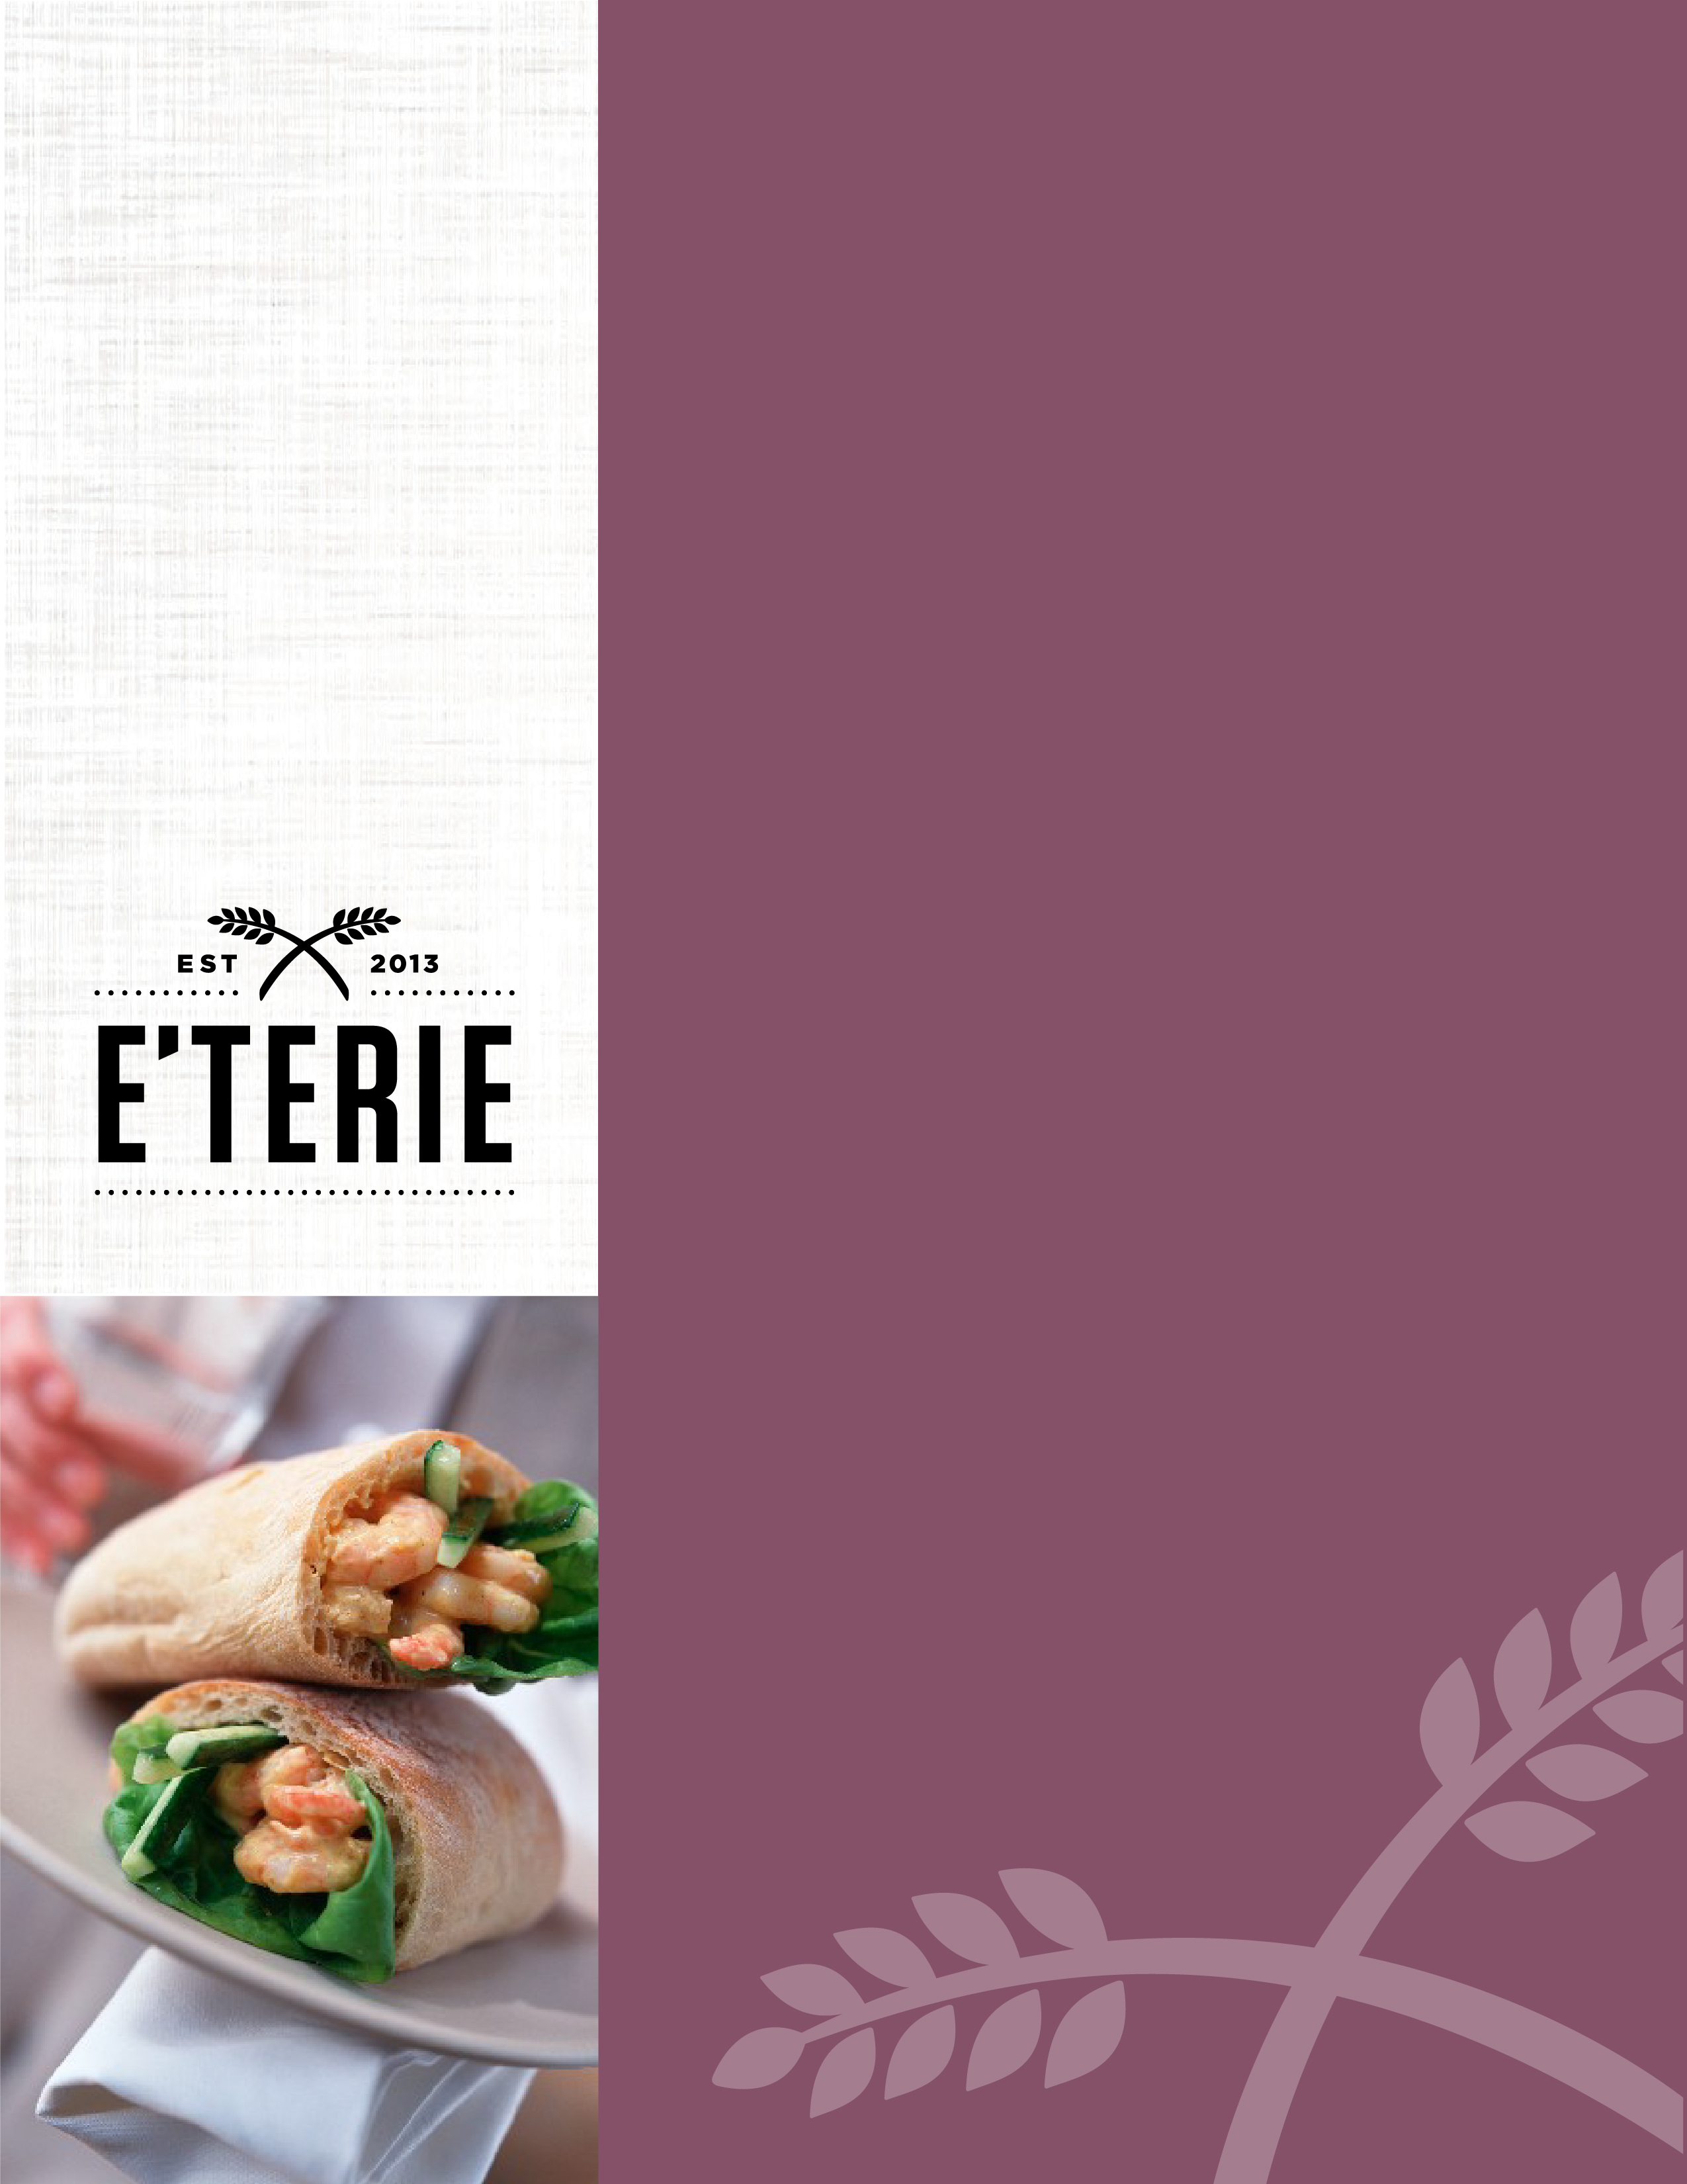
E’TERIE STANDARD OPERATING PROCEDURES
General
Guest service

All Team Members
2.1.0

E’TERIE STANDARD OPERATING PROCEDURE
General guest Service

E’terie PROMISE/STANDARD

E’terie promises to consistently deliver excellent guest service in the spirit of our brand pillars of Quick, Mindful and Genuine by upholding the tenets outlined below.

TEAM MEMBER CONTRIBUTION
- Team members should acknowledge approaching guests with a smile and greeting – using their first and last name if known.
- Guests should be welcomed in their own language, if possible. If it is not clear which country the guest is from, or their language isn’t spoken, team members should greet them in the local language and with a smile.
- When busy, team members should acknowledge waiting guests and, when appropriate, greet them with a mention that they will be served as soon as possible.
- Eye contact should be maintained and the guest’s name used in conversation if known.
- Team members should use an enthusiastic and sincere tone of voice, while also steady and calm to communicate serenity to the guest. Our words and tone should be in the spirit of being Mindful and Genuine.
- After assisting a guest, team members should:
  - Ask if they need anything else.
  - Invite the guest to contact them or one of the other E’terie team members if additional needs or questions arise.
  - Thank the guest for their business.
- Any children that arrive at E’terie with their parents should be acknowledged.
- If a guest’s request cannot be immediately handled, another E’terie team member who can assist with the problem should be contacted. The guest should immediately be informed of who is now handling their request and when it will be satisfied.
- E’terie team members must be knowledgeable about the facility and the hotel’s general services, amenities and features.
- When asked for directions around the hotel, refer the guest to the Front Desk.
- Team members should always open and hold doors for guests.
- All team members must appear professional and well-groomed, consistent with the E’terie and hotel’s standards.
- Personal conversations are prohibited within guest proximity. Conversations between E’terie associates must be terminated immediately when a guest approaches.
- Conversations regarding complaints, problems or situations are prohibited within guest proximity.
- Personal items are not permitted in the work area. Store all in the staff room.
- Personal beverages, food and chewing gum are not allowed in E’terie, except for in designated staff areas.
- The counter must be attended at all times. Under no circumstances should the E’terie be left without a staff member for any amount of time.
- Team members must maintain good posture while in the presence of a guest. Leaning, sitting, slouching, or crossed arms are not allowed.
- Guests should not be approached for personal reasons.
LEADERSHIP CONTRIBUTION
- Managers will set the example for all team members by consistently demonstrating the behaviors outlined above.
- Managers will conduct regular audits and provide positive feedback to their team, or feedback for improvement, to support successful future interactions with our guests.

COMMITMENT ACCEPTED – Team Member
Name:
Role:
Date:
Signature:

COMMITMENT ACCEPTED – Leader

Name:
Role:
Date:
Signature:

